Travelling Salesman Problem: THEME PARK
Question Worksheet

TASK

You are helping to organise a school trip to Hamilton’s Adventure Park in October.

Your teacher is arranging the transport. A coach will drop you off at the Park gates at 10am, but they need to know what time you will be leaving. The coach will be staying at the Park until you are ready to leave and will be charging an hourly rate during this time. The school is funding the trip, although they only have a limited budget and they want to make it as cheap as possible.

Therefore, in order to keep the transport costs as low as possible, it is up to you to plan the quickest route around Hamilton’s Adventure Park. As you will have standard tickets, you need to allocate time to queue for entry to the Park. You will also need to allow time for you and your friends to visit each main attraction once before returning to the Park gates, and include a 30 minute lunch break.

INFORMATION GATHERING

- What information do you need to consider for this task?

- Lunch Break length,
- How far apart rides are (distance)
- How long rides taken to queue,
- How long rides take to complete (duration)
- What time you start

- Complete the table below to complete the network and show the quickest routes between all attractions

 | Park Gates | Animal Kingdom | Carnival Land | Corkscrew | Log Flume | Wonder Wheel | The Hole | Roller Coaster
Park Gates | - | 8m | 12m | 11m | 14m30s | 14m | 23m | 22m30s
Animal Kingdom | 8m | - | 20m | 3m | 6m30s | 20m | 17m30s | 29m30s
Carnival Land | 12m | 20m | - | 23m | 20m | 6m30s | 15m30s | 10m30s
Corkscrew | 11m | 3m | 23m | - | 6m30s | 20m | 17m30s | 28m
Log Flume | 14m30s | 6m30s | 20m | 6m30s | - | 13m30s | 11m | 21m30s
Wonder Wheel | 14m | 20m | 6m30s | 20m | 13m30s | - | 9m | 9m30s
The Hole | 23m | 17m30s | 15m30s | 17m30s | 11m | 9m | - | 10m30s
Roller Coaster | 22m30s | 29m30s | 10m30s | 28m | 21m30s | 9m30s | 10m30s | -

UPPER AND LOWER BOUNDS

Lowest Upper Bound - Nearest Neighbour Algorithm

- Pick any starting vertex
- Consider the edges that join the starting vertex to other vertices. Pick the edge with the minimum weight and add this to the cycle
- Repeat step 2 until all vertices have been chosen
- Add the edge that joins the last vertex to the first vertex to complete the cycle

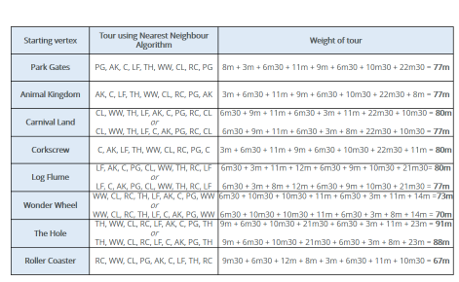
3. Applying the Nearest Neighbour Algorithm, complete the Table below:

- What is the Lowest Upper Bound?
67 minutes
……………………………………………………………………………………………………………………………………………………

- Solution

b. Using the tour time from Question a. and the information from Question 1, use the space below to outline how long you will be in the Park altogether and what time you will need the coach to collect you from the Park Gates.

The total time at Hamiltons Adventure Park is 477 minutes (7 hours 57 minutes).

This is made up from the total tour time (67 minutes) plus queing / ride time for attractions (350 minutes), plus entry to the park (30 minutes) plus a lunch break (30 minutes).

We now know that 8 hours is the minimum required time to visit Hamilton’s Adventure Park in October. Therefore, as the coach is dropping you off at the Park Gates for 10am, it will need to collect you again at 6pm.

*This point can be up for discussion – What about toilets?
*Some of you may have decided to allocate an extra hour in the Park for toilet breaks, snacks, or extra rides. In which case, the coach will need to collect you from the Park Gates at 7pm instead.

We would have started at the Roller Coaster, then gone to the WonderWheel, then the Carnival Land, then the Park Gates, then the Animnal Kingdwom then the Corkscrew, then the Log Flume then the The Hole and finally the Rollercoaster.

