

`

Hamilton’s Adventure Park
VISITORS GUIDE

Park Opening Times
Hamilton’s Adventure Park is open from 9am to 9pm every day. We are closed on Christmas Day, Boxing Day, and New Year’s Day.

Entry to the Park
The Park Gates can be extremely busy. Standard Ticket Holders may queue for up to 30 minutes to enter the Park.

Season Passes accepted
Hamilton’s Adventure Park accepts Monthly and Annual season passes as well as entry bought at the park gates.

To help you plan your visit, these are our maximum overall queue and ride times for our main attractions throughout the year:
The Operational Research Society
 www.theorsociety.com
@TheORSociety or @ORinSchools
Facebook.com/TheORSociety

This leaflet has been designed by the education team at The OR Society for use as a maths teaching resource. For more free teaching resources or to request a maths career talk, visit The OR Website or email schools@theorsociety.com
PARK GATES
CARNIVAL LAND
ANIMAL KINGDOM
CORKSCREW
LOG FLUME
WONDER WHEEL
ROLLER COASTER
THE HOLE

Food / refreshments kiosks and toilet facilities are located throughout the Park

To help you make your way around the Park, our map includes the average time to travel directly between our main attractions
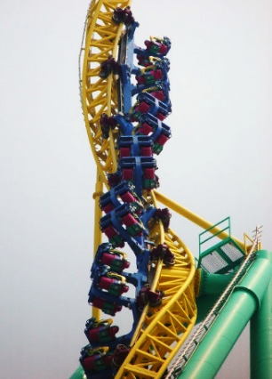
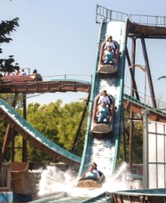

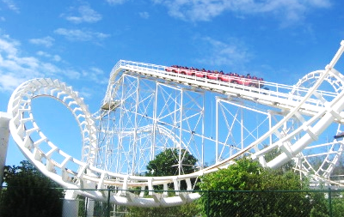



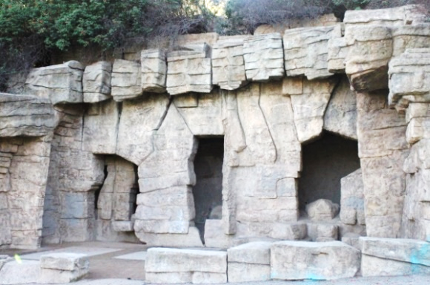

8m
12m
10m30s
3m
6m30s
6m30s
11m
14m
13m30s
9m
6m30s
9m30s
10m30s

